Please indicate all the regions you are experiencing pain currently.

If you do not have current pain check here: _ No Current Pain

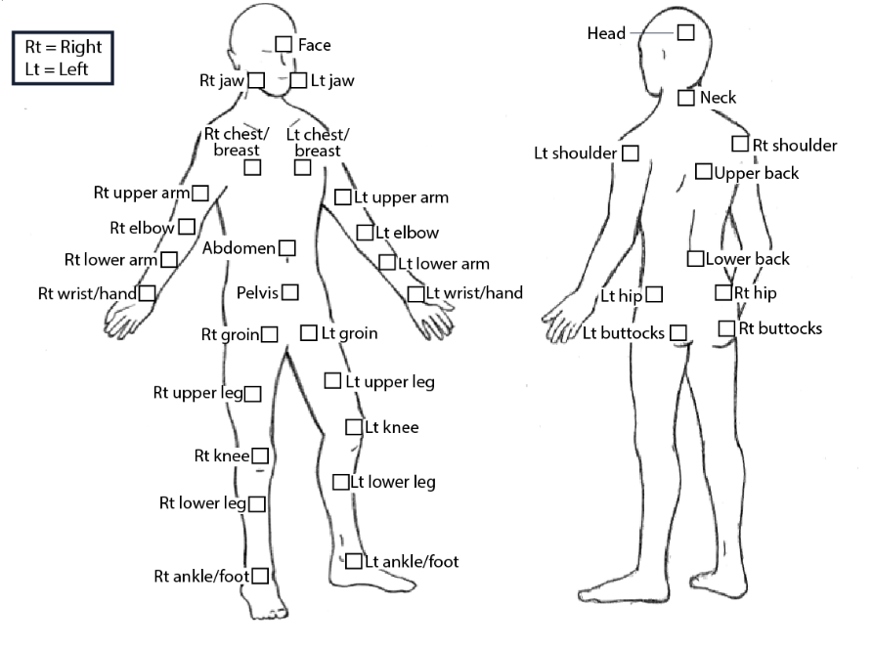

Figure 1. Body images for the Michigan Body Map.

Body areas that can be selected:
Image of body front
Face
Right jaw
Left jaw
Right chest/breast
Right upper arm
Right elbow
Right lower arm
Right wrist/hand
Left chest/breast
Left upper arm
Left elbow
Left lower arm
Left wrist/hand
Abdomen
Pelvis
Right groin
Right upper leg
Right knee
Right lower leg
Right ankle/foot
Left groin
Left upper leg
Left knee
Left lower leg
Left ankle/foot

Image of body back
Head
Neck
Left shoulder
Left hip
Left buttocks
Right shoulder
Upper back
Lower back
Right hip
Right buttocks

Copyright 2015 Regents of the University of Michigan

Notes:
Instrument is available at the University of Michigan website, at https://medicine.umich.edu/dept/pain-research/clinical-research/michigan-body-map-mbm

A sum score (MBM Total) can be obtained by counting the checked body areas.

Reference:
Brummett CM, Bakshi RR, Goesling J, Leung D, Moser SE, Zollars JW, Williams DA, Clauw DJ, Hassett AL. Preliminary validation of the Michigan Body Map. Pain. 2016 Jun;157(6):1205-12. doi: 10.1097/j.pain.0000000000000506. PMID: 26835782; PMCID: PMC4868633.

