Where is your pain? Please mark the areas on your body where you feel the described sensations.

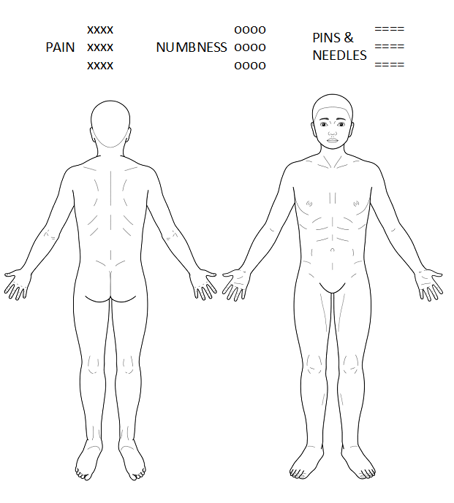

Figure 1. Body drawing for indicating location of pain, numbness, or pins & needles.

References
Hannover body template (Neubert T, Beissner F. Figshare. 2019. [2019-08-15]. Hannover Body Template https://figshare.com/articles/Hannover_Body_Template/7637387/5)

Method described by Ohnmeiss (Ohnmeiss DD. Repeatability of pain drawings in a low back pain population. Spine. 2000 Apr 15;25(8):980–8)

Scoring method described by Margolis (Margolis RB, Tait RC, Krause SJ. A rating system for use with patient pain drawings. Pain. 1986 Jan;24(1):57–65).

